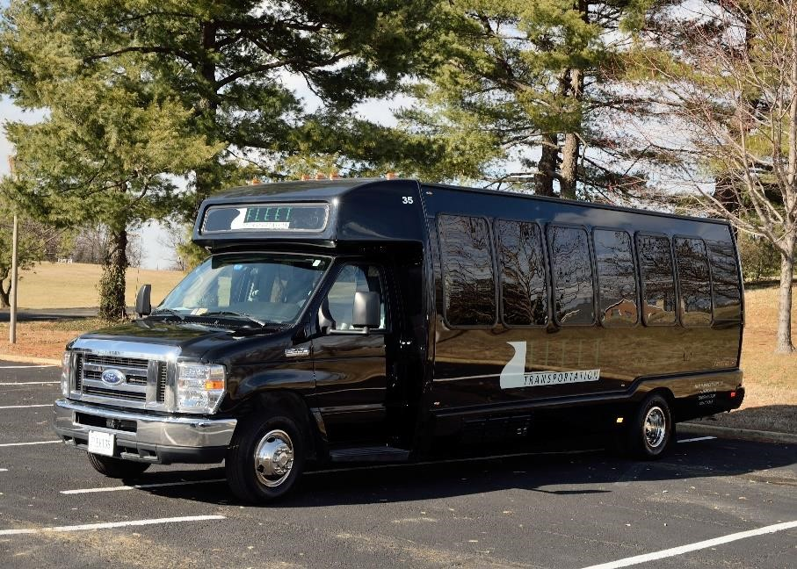
Potomac Yards
Shuttle Service To/From Crystal City Metro
Pickup and drop off at 1750 South Bell Street Arlington, VA 22202 Shuttle service is operated by Fleet Transportation, LLC
Tuesday, Wednesday, and Thursday Service
AM SERVICE |  |  |  | PM SERVICE
Potomac Yards | Crystal City Metro |  |  | Crystal City Metro | Potomac Yards
5:55 AM | 6:15 AM |  |  | 4:00 PM | 4:15 PM
6:25 AM | 6:45 AM |  |  | 4:40 PM | 4:55 PM
6:55 AM | 7:15 AM |  |  | 5:20 PM | 5:35 PM
7:25 AM | 7:45 AM |  |  | 6:00 PM | 6:15 PM
Shuttle leaves promptly at scheduled time.
- Powatan- Corner of Powatan and Slater Ln.
- Porter Del Ray – Main Entrance
- Station 650 – Corner of Main Line Blvd and Potomac Ave
- Kiosk at Main Line Blvd and E Howell Ave
- Kiosk at Main Line Blvd and East Custis Ave
- Main Line Blvd and Swann Ave
- Notch 8 – Main Entrance

